
Department | FED
Subject | DSA-2
Academic Year | I-III Semester (2025-26)
Faculty Name | MD Razia
Student Name | VUNGARALA MOUKTHIKA
Roll Number | 2520030298
Branch | CSE
Course Outcome | CO1

Case Study Topic: WhatsApp Delivered-Receipts Ordering using AVL Tree
Work Done Summary:
In this case study, we analyzed a backend service that stores WhatsApp message delivered-receipts using timestamps in descending order. The system receives approximately 5,000 messages per second and requires efficient retrieval of the oldest pending receipt.
A plain Binary Search Tree (BST) was evaluated first. Since timestamps are inserted in strictly increasing order, the BST becomes highly skewed, resulting in poor performance. We then analyzed an AVL Tree as an alternative and compared the lookup times against the given SLA requirement of 500 microseconds.
The study demonstrates that AVL Trees maintain balance automatically and provide significantly better performance for large-scale messaging systems

Implementation Details:
- Considered an insertion rate of 5,000 messages per second for one hour.
- Calculated total inserted nodes:
  - n = 5000 × 3600 = 18,000,000
- Analyzed BST behavior under strictly increasing timestamps.
- Determined BST height becomes approximately equal to n, creating a skewed tree.
- Calculated worst-case lookup time for finding the oldest pending receipt.
- Evaluated AVL Tree height using:
  - h ≤ 1.44 log₂(n)
- Compared AVL lookup performance with the required SLA.
- Concluded AVL Tree is the suitable data structure for this application.

Result: Screenshots / Output
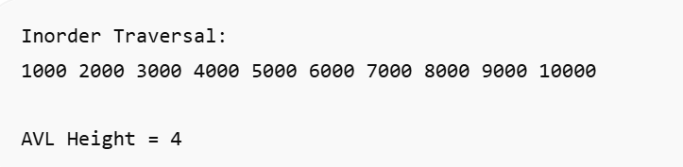
Time Complexity:
- Insert: O(log n)
- Search: O(log n)
- Delete: O(log n)
Space Complexity:
- O(n)

GITHUB LINK : https://github.com/srikarputta2007-png/DSA-II-

Student Signature | Faculty Signature

